# CSE 4020 - MACHINE LEARNING

# Lab 29+30

# Lab CAT

# Submitted by: Alokam Nikhitha(19BCE2555)

**Question:**

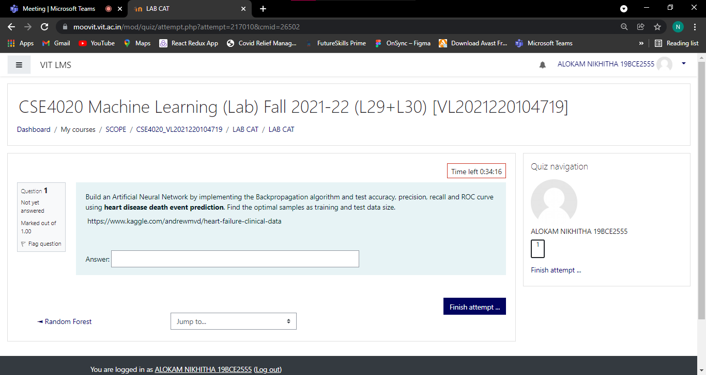

Build an Artificial Neural Network by implementing the Backpropagation algorithm and test accuracy, precision, recall and ROC curve using **heart disease death event prediction**. Find the optimal samples as training and test data size.

 https://www.kaggle.com/andrewmvd/heart-failure-clinical-data

**Dataset Used:**

https://www.kaggle.com/andrewmvd/heart-failure-clinical-data

**Procedure:**

* **Firstly we are importing the Libraries**
* **We are importing the dataset using pandas**
* **Here we displayed the first 10 rows of the dataset.**
* **We identified Dependent and Independent variables in the dataset.**
* **Splitting the dataset in to Testing and Training sets.**
* **Feature Scalling the data**
* **Later, We initialized th ANN**
* **We displayed the Accuracy, Precision**
* **We plotted the ROC graph using Matplot Library**

**Code Snippets and Explanation:**

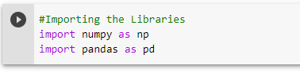

Here we are importing the libraries.



Here we are importing the dataset using pandas.

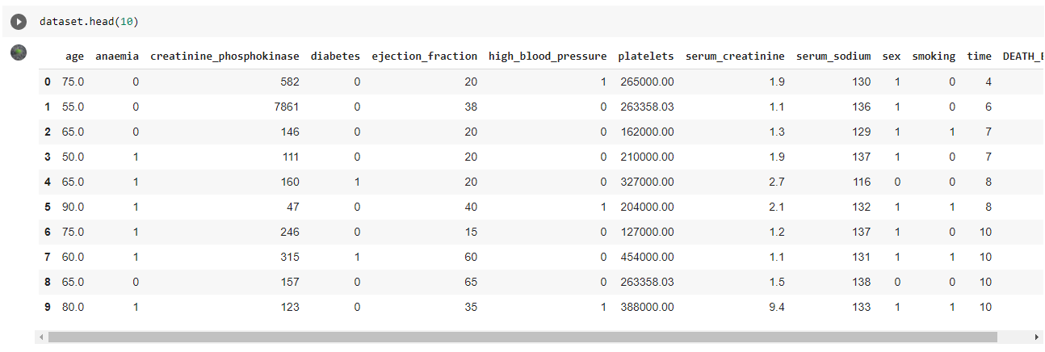

Here we displayed the first 10 rows of the dataset. 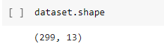

Displaying the size of Dataset

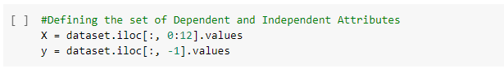

Identifying Dependent and Independent variables in the dataset.

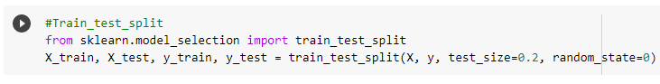

Splitting the Testing and Training sets.

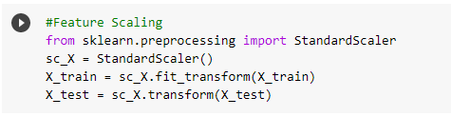

Feature Scalling the data

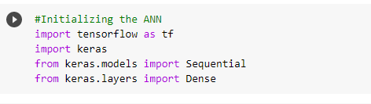

Initializing the ANN

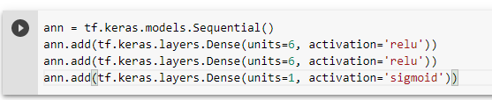



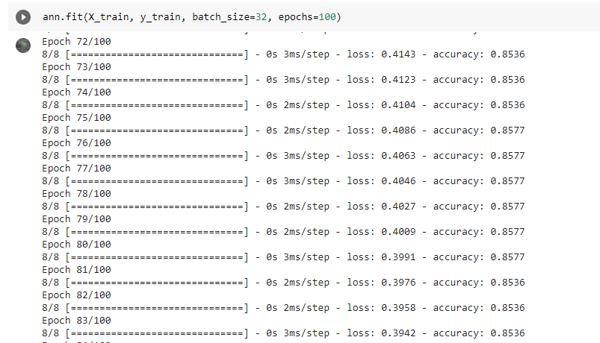

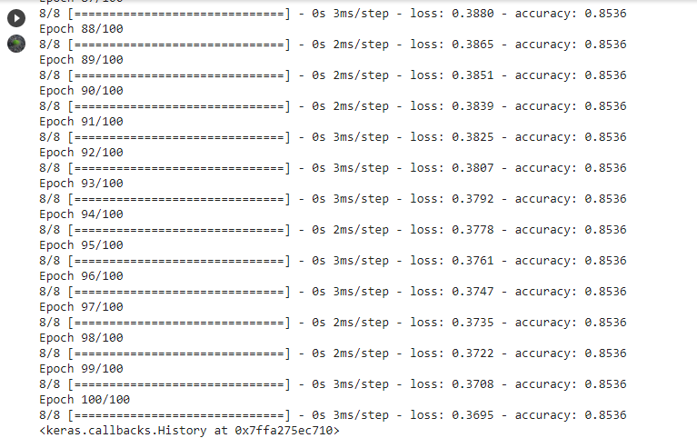



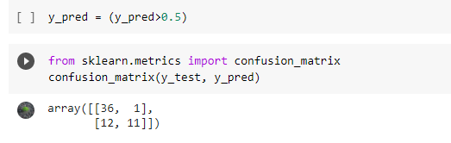

Confusion Matrix

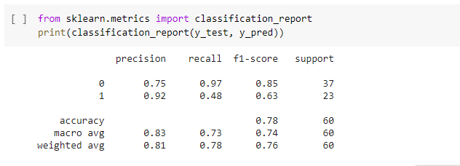

Precision of the Given Dataset

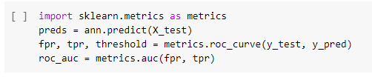

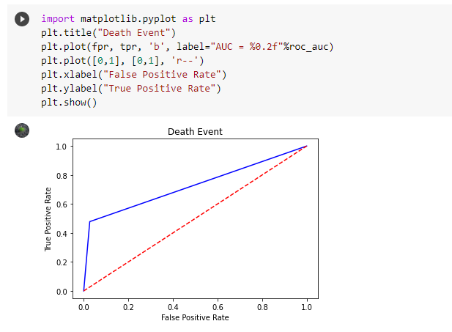

ROC Graph

**Results and Conclusion:**

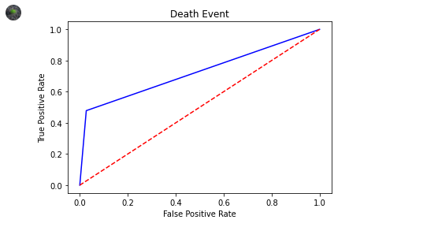

**ROC Graph**

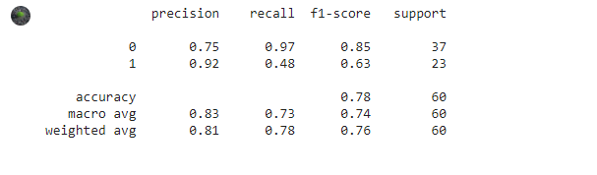

**Precision**

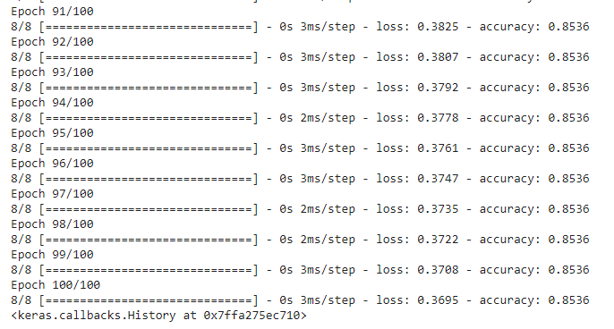

**Accuracy is 85.36%**